CTNNB1 (S33F)
Catalog Number: CR-M26304
Gene Symbol: Beta-catenin, CTNNB, Catenin beta-1
Description: Anti-CTNNB1 (S33F) Mouse Monoclonal Antibody

Background: CTNNB1 protein is a dual function protein. It is a subunit of a complex of proteins that from adherens junctions, which are important for the establishment and maintenance of epithelial cell layers by regulating cell growth and adhesion between adjacent cells. CTNNB1 protein also pulls double duty as an intracellular signal transducer in the Wnt signaling pathway. Mutations of CTNNB1 have been implicated in the pathogenesis of several cancers.
Immunogen: A synthetic peptide from the internal region of CTNNB1 which includes the mutation of S33F, human origin.
Tested applications: ELISA, WB, IHC
Recommended dilutions:
ELISA: 1:1000-1:5000
WB: 1:500-1:1000
IHC: 1:50-1:100
Concentration: 2 mg/ml
Host: Mouse
Clonality: Monoclonal
Purity: Purified from ascites
Format: Liquid
Storage buffer:
Preservative: no
Constituents: PBS (without Mg²⁺ and Ca²⁺), pH 7.4, 150 mM NaCl, 50% glycerol
Species Reactivity: Recognizes S33F mutant, but not wild-type CTNNB1 of vertebrates.
Storage Conditions: Store at -20°C. Avoid freeze / thaw cycles.

Western blot:
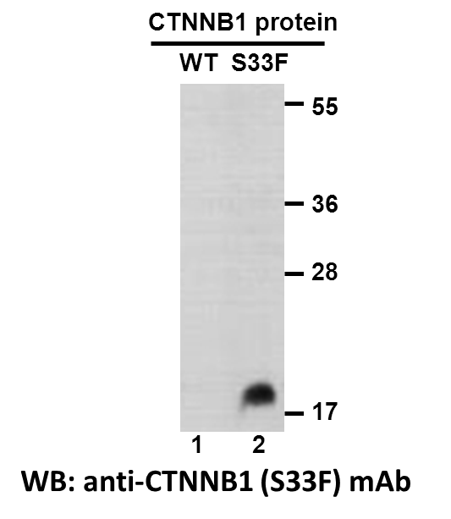
Western blot analysis of recombinant CTNNB1 (S33F) and wildtype proteins. Purified His-tagged CTNNB1 (S33F) protein (lane2) and corresponding wild-type protein
(lane1) were blotted with anti-CTNNB1 (S33F) monoclonal antibody (Cat. #26304).

Immunofluorescence:
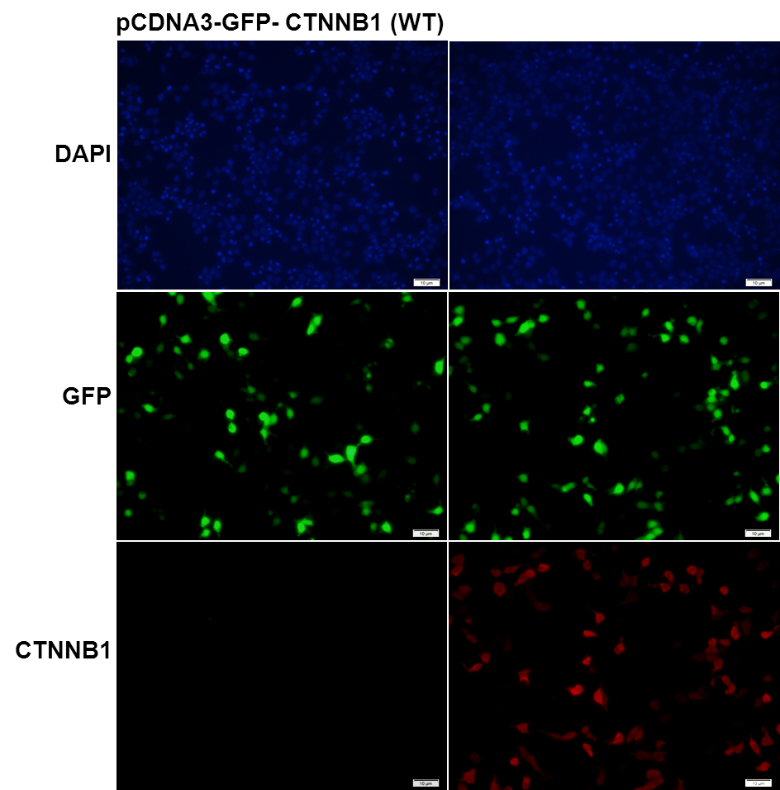
Immunofluorescence of cells expressing CTNNB1 proteins with anti-CTNNB1 (S33F) antibody. HEK293T cells were transfected with pCDNA3-GFP-CTNNB1 (WT) plasmid (left column) or pCDNA3-GFP-CTNNB1 (S33F) plasmid (right column), then fixed and stained with anti-CTNNB1 (S33F) monoclonal antibody (Cat. #26304).

科博瑞（武汉）生物科技有限公司
TEL：027-87615885 15972062685
- mail：3636901710@qq.com
Web:www.coburybio.com

